**9th SPINE Summer School 2023**

Designing Behavior Change Interventions in Healthcare

**Lausanne, August 28-31, 2023**

The **2023 SPINE Summer School** will bring international scholars and PhD students together to learn designing behavior change interventions in healthcare. The Summer School 2023 will be held in Lausanne and offers a mix of lectures and active group work led by senior researchers from different fields, formative feedbacks from peers and experienced researchers to foster interaction and critical thinking.

This year summer school introduces participants to key behavioural science tools and demonstrates how they interlink to guide the development and implementation of behaviour change interventions. These tools are known collectively as the ‘BCW toolkit’ and include:

* COM-B model *(Michie et al., 2011)*: a simple approach to understanding behaviour in context, the COM-B model forms the hub of the BCW and specifies three conditions (Capability, Opportunity and Motivation) that are necessary for a given behaviour to occur;
* Behaviour Change Wheel (BCW) *(Michie et al., 2011)*: a synthesis of 19 behaviour change frameworks identified in a systematic literature review, relating to areas such as health, environment, culture change and social marketing;
* Behaviour Change Techniques Taxonomy v1 (BCTTv1) *(Michie et al., 2013)*: a structured list of 93 techniques to change behaviour developed using a series of consensus processes building on existing taxonomies developed for specific behaviours.

The course will also build participants’ knowledge in other methodologies such as ‘co-design’ to demonstrate how to blend these methodologies together and further tailor behaviour change interventions.

9th SPINE Summer School 2023

Organisers

SPINE is an educational platform for doctoral students working towards a PhD in Nursing Science at the Universities of Lausanne and Basel. SPINE provides educational courses and Summer schools for doctoral students in nursing and other health-related disciplines, along with other events, such as the Doctoral Research Day.

SPINE Directors

Prof. Anne-Sylvie Ramelet

[anne-sylvie.ramelet@chuv.ch](mailto:anne-sylvie.ramelet@chuv.ch)

+41 (0) 21 314 23 05

Prof. Michael Simon

[m.simon@unibas.ch](mailto:m.simon@unibas.ch)

+41 (0) 61 207 09 12

Learning objectives:

By the end of this course, participants will be able:

* Uncover the key principles of the Behaviour Change Wheel (BCW) Toolkit
* Understand how the BCW tools interlink and build upon each other
* Learn how the BCW has been applied in practice for designing healthcare interventions
* Build knowledge and skills in designing behaviour change interventions
* Learn how to apply specific criteria for making context-based implementation decisions
* Apply the core principles of intervention design to your own projects

The 2023 Summer School is a 4-day intensive course including lectures and group work.The course will be taught in English. Participants will also have the opportunity to discuss their own research project.

Registration Deadline is June 30th 2023

9th SPINE Summer School 2023

**Faculty**



Dr Kristina Curtis

Dr Kristina Curtis is a consultant, researcher, lecturer and trainer in behaviour change intervention design and implementation. Kristina’s expertise involves using multi-disciplinary approaches for the development of digital behaviour change interventions (DBCIs) for improving health and wellbeing. Kristina has worked on a range of projects within the areas of weight management, physical activity and self-management of chronic conditions. Kristina leads a behavioural science consultancy (Applied Behaviour Change) offering consultancy, contract research and training for a range of organisations. Kristina is also an honorary lecturer and associate of University College London (UCL) Centre for Behaviour Change and delivers regular teaching and student supervision in behavioural science.

**Assistant**

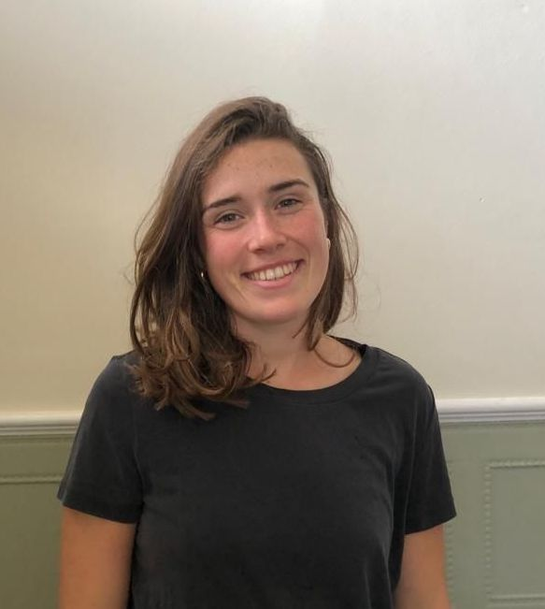Ms. Ella Howes

Ms. Ella Howes has worked as a research assistant in translational behavioural science on the Human Behaviour-Change Project since 2020. She is particularly interested in how we can improve the design and reporting of behaviour change interventions. In October 2023, Ella will begin a PhD exploring the remote delivery of complex interventions at the University of Leeds.

Ella has been involved in a number of consultancy projects at the Centre for Behaviour Change (CBC) and has delivered training on the Behaviour Change Wheel to a number of organisations.

|  |  |  |
| --- | --- | --- |
| Day | Topic | Time |
| Day 1: 28 Aug |  |  |
| Monday | Welcome & Introductions | 10.00 |
|  | Overview of the training programme | 10.30 |
|  | Module 1: Understanding Behaviour | 10.45 |
|  | Coffee Break | 11.45 |
|  | Module 1: Case studies | 12.00 |
|  | Module 2: Theories and Models of Behaviour Change | 12.30 |
|  | Lunch | 13.00 |
|  | Module 2: Making a COM-B diagnosis (CO) | 14.00 |
|  | Coffee Break | 15.00 |
|  | Module 2: Case studies | 15.30 |
|  | Discussion | 16.00 |
|  | Close | 16.30 |
| Day 2: 29 Aug |  |  |
| Tuesday | Welcome | 10.00 |
|  | Recap of Day 1 Learning outcomes | 10.15 |
|  | Module 2: Making a Motivational Diagnosis | 10.30 |
|  | Coffee Break | 11.15 |
|  | Module 2: Making a Motivational Diagnosis | 11.30 |
|  | Module 2: Case studies | 12.30 |
|  | Lunch | 13.00 |
|  | Module 3: Selecting Intervention Types | 14.00 |
|  | Module 3.1 Case studies | 14.30 |
|  | Coffee Break | 15.15 |
|  | Discussion | 15.45 |
|  | Close | 16.30 |
|  | Social event for all | 17:30 |
| Day 3: 30 Aug |  |  |
| Wednesday |  |  |
|  | Welcome | 10.00 |
|  | Recap of Day 2 Learning outcomes | 10.15 |
|  | Module 3: Selecting policy options | 10.30 |
|  | Module 3.2: Case studies | 11.00 |
|  | Break | 11.15 |
|  | Module 4: Selecting BCTs | 11.30 |
|  | Lunch | 13.00 |
|  | Module 4: Selecting BCTs & Case studies | 14.00 |
|  | Coffee Break | 15.00 |
|  | Module 4: Case studies & Discussion | 15.30 |
|  | Close | 16.00 |
|  | Dinner for faculties and speakers | 19:30 |
| Day 4: 31 Aug |  |  |
| Thursday | Welcome | 9.30 |
|  | Recap of the whole programme | 9.45 |
|  | Module 5: Implementation | 10.00 |
|  | Coffee Break | 11.15 |
|  | Showcases | 11.30 |
|  | Lunch | 13.00 |
|  | Showcases | 14.00 |
|  | Coffee Break | 15.15 |
|  | Discussion and next steps | 15.45 |
|  | Close | 16.30 |

Note: Highlights are group works

Training Format

The course is divided into 4 days of training, each day includes:

* Delivery of module content (5 X modules)
* Healthcare examples and activities for each module
* Working in groups on a selected case study to demonstrate each stage of the BCW process*
* Q&A session with training facilitators
* Workbook to record your behaviour change plans and reflections on the BCW process

*Each group will showcase their case study to the wider group on day 4

Suggested Readings:

* Michie, S., Atkins, L., & West, R. (2014). A guide to using the Behaviour Change Wheel. London: Silverback Publishing.
* Michie, S., van Stralen, M. M., & West, R. (2011). The behaviour change wheel: A new method for characterising and designing behaviour change interventions. Implementation Science, 6, 42.
* Michie, S., Richardson, M., Johnston, M., Abraham, C., Francis, J., Hardeman, W., Eccles, M.P., Cane, J., & Wood, C.E. (2013). The behavior change technique taxonomy (v1) of 93 hierarchically clustered techniques: building an international consensus for the reporting of behavior change interventions. Ann Behav Med, 46 (1), 81-95.
* West, R., Michie, S., Atkins, L., Chadwick, P., & Lorencatto, F. (2019). Achieving behaviour change: A guide for local government and partners. Report can be accessed at: <https://assets.publishing.service.gov.uk/government/uploads/system/uploads/attachment_data/file/> 875385/PHEBI_Achieving_Behaviour_Change_Local_Government.pdf

Preparation work

Readings will be provided for each day

<https://drive.switch.ch/index.php/s/OgBwUpGWQAKXawf>

Dates

Monday 28th to Thursday 31th August 2023

Venue

Lausanne, CHUV, Lausanne University Hospital

Schedule Time

Please see program

Commitment and Credits

6 hours of lecture/ seminar per day

3 hours preparation per day

**2 ECTS**

Target Group and Eligibility

Doctoral students and post-doctoral fellows, faculty members and researchers from Nursing Science and healthcare disciplines. Participants should have successfully completed graduate level courses in qualitative research methodology and be familiar with health research concepts.

Registration – Deadline June 30th 2023

* Please register via this [link](https://wwwfbm.unil.ch/sondage/index.php/867426?lang=en)
* Recent CV (2 pages max)
* Copy of higher degree or letter from PhD supervisor

Course Fees*

* PhD students affiliated with SPINE (INS, UNIL) and PPHS: Free

- PhD students not affiliated with SPINE or PPHS**: CHF 720

* Post-doctoral fellows: CHF 720

- INS- and UNIL Alumni: CHF 720

- Other participants: CHF 1’120

*The course fee includes course materials. Registration is conditional upon full payment of fees.

**To qualify for the PhD fee, applicants not affiliated with SPINE are required to submit a letter from their supervisor stating their actual position as a doctoral student or postdoctoral fellow.

Payment

Through invoice

Payment of fees is due within 3 weeks of notification of acceptance and should be received at the latest by August 13th 2023.

Terms, Conditions, and Cancellation Policy

• Seating is limited to 40 participants. All participants must commit to attending the full 4-day course. Applicants are selected on a first come first serve basis. Only complete applications are considered. Notification of acceptance will be emailed within 2 weeks of the closing date.

• In case of cancellation, a written notification must be sent. A service fee of CHF 50 will be charged. Refund will no longer be possible after July 18th 2023..

• The organization reserves the right to make minor program modifications, decline applications, or cancel the course in case of insufficient registrations at the closing date.

Contacts and Questions

Dr. Zahra Rahmaty

Route de la Corniche 10

1010 Lausanne, Switzerland

Phone: +41 (0)21 314 54 35

Zahra.rahmaty@chuv.ch